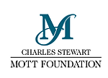
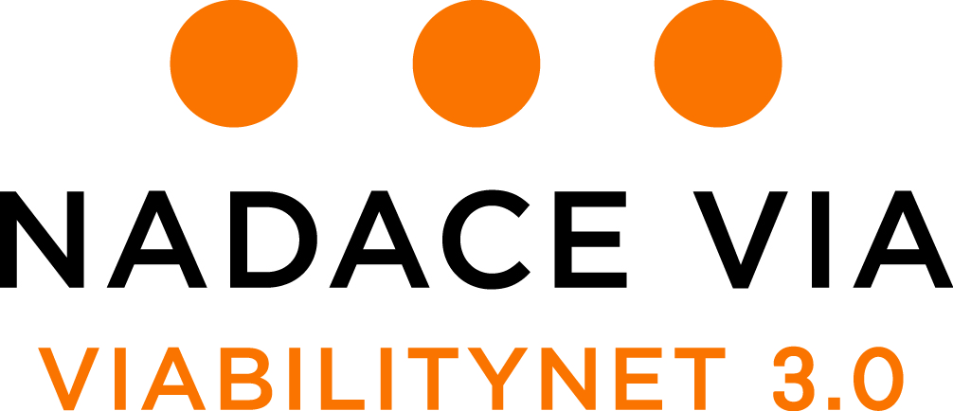

DECLARATION BY THE AFFILIATE ORGANIZATION | /
 | Application No. (Please leave blank)

Name of organization/legal entity:
Address:
Country:
Website: | Fax:
Legal form of organization: | Registration No.:
Bank:
Address of the bank:
Account No.:
SWIFT Code: |  | IBAN:
Name of statutory representative:
Telephone No.: |  | E-mail:
Vision and mission of your organization:

Briefly describe what your organization does:
What kind of support do you expect to provide to the ViabilityNet 3.0 participant affiliated with your organization?

SUMMARY OF INFORMATION FOR THE AFFILIATE ORGANIZATION

ViabilityNet 3.0 grants cannot be given to individuals. This is why participation in the program requires affiliation with a legal entity such as a civil association, foundation, public institution, public benefit company, etc., depending on each country’s legislation.

Affiliation for the purposes of ViabilityNet does not mean that the participant must be an employee, member or an elected representative of the organization.

The organization must be able and willing to receive funding through grants on behalf of the participant and allow him or her to disburse the funding as required. This may include travel costs, training courses, etc. Please make sure such expenses will be acceptable to your organization’s financial department if the participant is not an employee of your organization.

A flat fee (contribution) for the affiliate organization (6,000 CZK – approx. 230 EUR) to cover grant administration costs is included in one of the grants.

Prior to signing this declaration, we kindly ask the financial department staff of your organization to refer to the following documents, available for download at http://www.nadacevia.cz/en/viabilitynet, Documents section:
- Financial Guidelines
- Project Grant Agreement
- Travel Grant Agreement

GRANTS
Each participant will receive funding through two types of grants: a Project Grant and a Travel Grant. Organizations outside the Czech Republic will receive the grants in EUR (see Financial Guidelines for details on currency exchange rates) but the amounts are set in Czech Koruna (CZK).

PROJECT GRANT
The Project Grant is intended to cover the costs of the participant’s community project and individual learning activities (e.g. training courses, materials, study visits).

The project grant (60,000 CZK – approx. 2,300 EUR) will be transferred in two instalments.
- The first will follow the signing of the grant agreement (Autumn 2018) and will consist of 30,000 CZK.
- The second will be transferred after the submission of the Interim Report in February 2019 and will consist of 30,000 CZK.

The Project Grant Agreement includes a project description and a budget. The participant is expected to draft the budget in cooperation with the affiliate organization’s financial department to make sure all planned expenses can be included in the organization’s accounting.

Ineligible costs as defined by Via Foundation include the following:

- costs not directly related to the participant’s community project;
- costs incurred or services performed outside the timeframe of the program (as defined in the Project Grant Agreement);
- expenses for lobbying activities (communications — either to a legislator or to the general public — intended to influence specific legislation);
- activities conducted in the USA;
- purchase of real estate;
- servicing of debts, mortgages, interests, exchange losses or other banking fees;
- purchase of alcoholic beverages or tobacco.
A Project Grant Agreement between the participant, the affiliate organization and Via Foundation will be signed, giving the participant responsibility for:
- drafting a budget for his or her project in cooperation with the affiliate organization;
- carrying out of all project activities;
- making sure all expenditures are in line with the approved project and budget;
- submitting Interim and Final reports about the project activities.

It also places responsibilities on the affiliate organization for:
- registering all expenditures and income related to the Project in a way that ensures that all such entries remain easily discernible, opening a special bank account for the purpose if necessary;
- not using any portion of the grant without the approval of the participant;
- closely cooperating with the participant to draft his or her budget and the financial section of his/her Interim and Final reports.

TRAVEL GRANTS
Costs of travel to the selection meeting (70%) will be covered through a separate Travel Grant.

When accepted into the program, the participant will receive a Travel Grant to cover 70% of the travel costs for 4 meetings and participation of one team member in the final meeting.
- An advance amount (14,000 CZK – approx. 500 EUR) will be transferred at the start of the program as a first installment to the affiliate organization.
- After the final meeting, the final balance will be calculated: any unused funding should be returned to Via Foundation and any deficit of up to 6,000 CZK will covered by a second installment to the affiliate organization.
- Only transport costs may be covered by travel grant (this excludes, for instance, per diems).
- Copies of all travel bills must be submitted after every meeting.

This summary is meant for basic orientation only. Please refer to the documents mentioned above for further details. In case of any questions or doubts, please, contact the following program managers at Via Foundation:

Monika Novosádová
monika.novosadova@nadacevia.cz
Phone: +420 604 612 817

Petra Nová
petra.nova@nadacevia.cz
Phone: +420 732 389 770

DECLARATION

I hereby confirm that I have read and understood the information presented in this document and that our organization is able and willing to receive funding through grants on behalf of the participant and allow him or her to disburse the funding as required.

In………………, date: …………………….

…………………………………………………..
Name and Surname
Position within the organization

COMMENTS:
Should you have any comments regarding the arrangement, please use the space below.

